**Problem Statement**

To detect marks from a given answer sheet and display the topic of a subject where he needs to improve .

Answer Sheet :

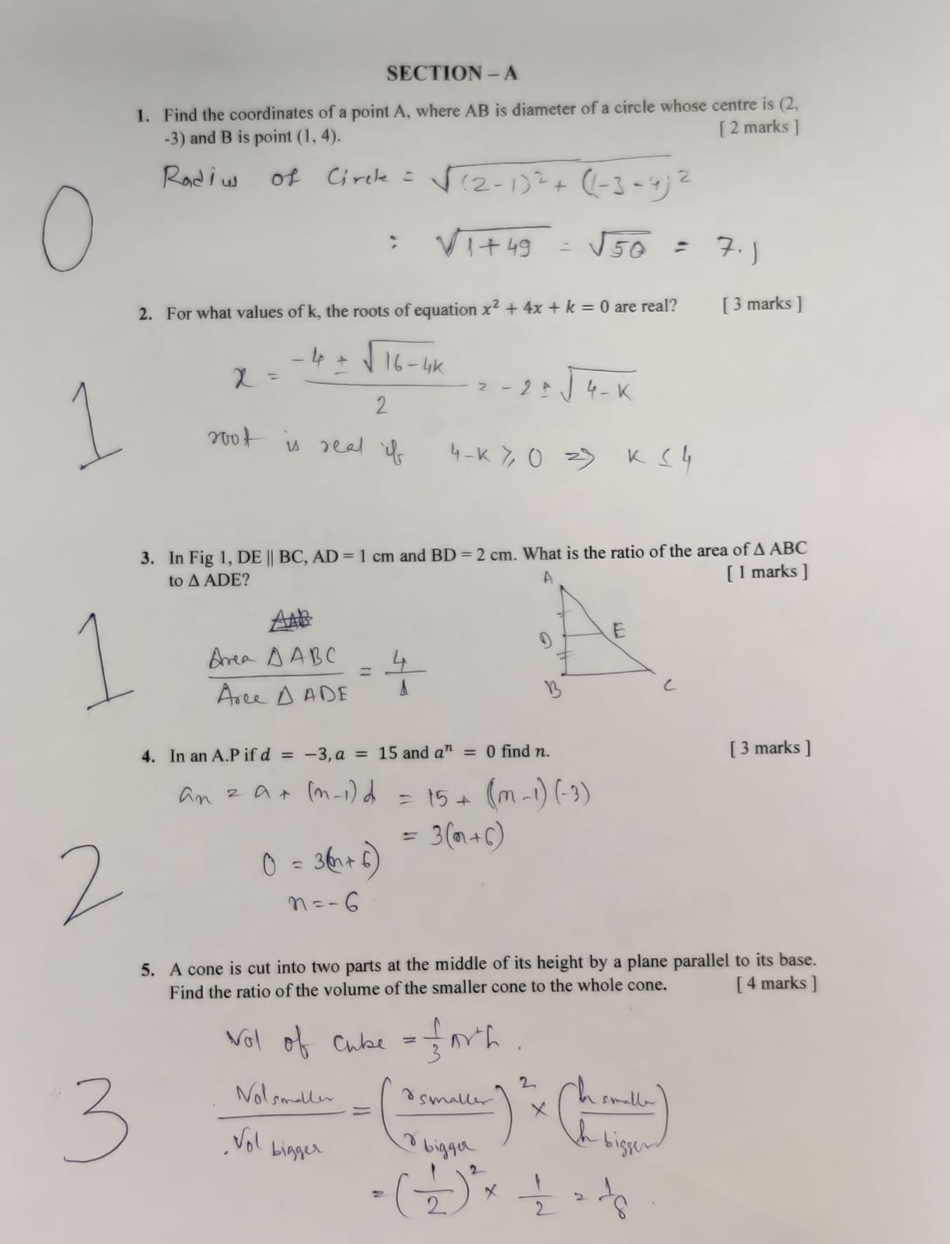

Syllabus:

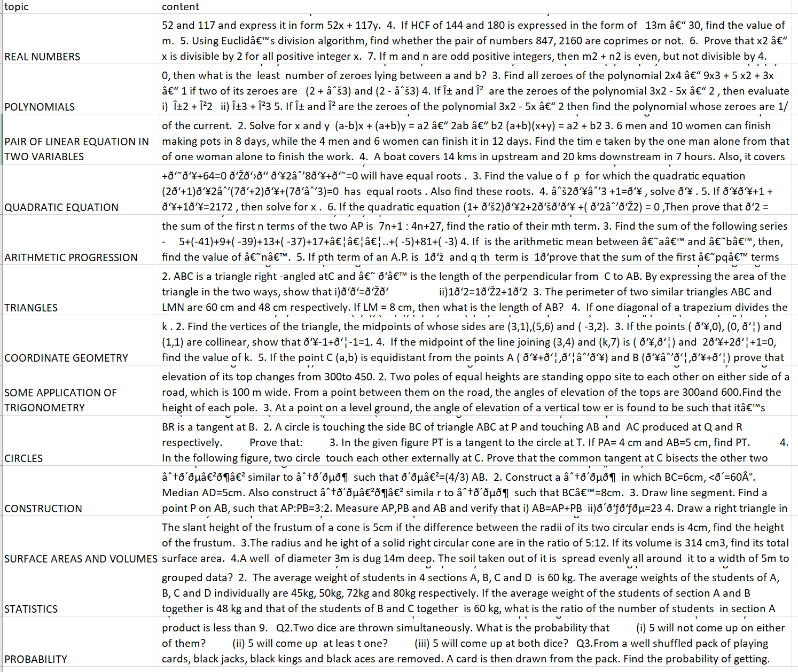

Output:



1/1 [==============================] - 0s 31ms/step

Question: 1. Find the coordinates of a point A, where AB is diameter of a circle whose centre is (2.

Topic: CIRCLES

Max Marks 2

Obtained Marks 0

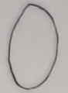



1/1 [==============================] - 0s 22ms/step

Question: 2. For what values of k, the roots of equation x? + 4x + k = 0 are real?

Topic: QUADRATIC EQUATION

Max Marks 3

Obtained Marks 1

--------------------------------------------------------------------------------



1/1 [==============================] - 0s 22ms/step

Question: 3. In Fig 1, DE || BC, AD = 1 cm and BD = 2 cm. What is the ratio of the area of A ABC

to A ADE? ‘ [ I marks ]

Topic: TRIANGLES

Max Marks 1

Obtained Marks 1

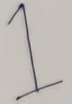

--------------------------------------------------------------------------------



1/1 [==============================] - 0s 24ms/step

Question: 4. InanA.Pifd = —3,a = 15 anda" = 0 findn.

Topic: ARITHMETIC PROGRESSION

Max Marks 3

Obtained Marks 2



1/1 [==============================] - 0s 395ms/step

Question: 5. Acone is cut into two parts at the middle of its height by a plane parallel to its base.

Find the ratio of the volume of the smaller cone to the whole cone. [4 marks }

Topic: SURFACE AREAS AND VOLUMES

Max Marks 4

Obtained Marks 3

